Section 1: Case Summary

Scenario Title: | Urologic Sepsis and Shock
Keywords: | Urologic emergency, sepsis, septic shock
Brief Description of Case: | Denise is a 59-year-old female who presents with a 7-day history of urinary symptoms, fever, and started with left flank pain. She has a history of STEMI 5 years ago. She then becomes unstable requiring fluid resuscitation, vasopressors, and empiric antibiotic treatment. The team leader will manage a patient with severe sepsis secondary to an infected ureteric calculus then arrange emergent urologic consultation and admission to hospital.

Goals and Objectives
Educational Goal: | Review the initial assessment and management of a patient with acute flank pain and fever.
Objectives:  (Medical and CRM) | 1. Early recognition of sepsis and identifying a likely source of infection  2. Timely implementation of broad-spectrum antibiotics and source control  3. Eliminate other differential diagnoses of shock  4. Management of a hemodynamically unstable patient with fluid resuscitation, vasopressors and appropriate monitoring  5. Appropriate hospital disposition of the patient
EPAs Assessed:

Learners, Setting and Personnel
Target Learners: | ☒ Junior Learners |  | ☐ Senior Learners |  |  | ☐ Staff
 | ☒ Physicians | ☐ Nurses |  | ☐ RTs | ☐ Inter-professional
 | ☐ Other Learners:
Location: | ☒ Sim Lab |  | ☐ In Situ |  |  | ☐ Other:
Recommended Number of Facilitators: | Instructors: 1
 | Confederates: 1
 | Sim Techs: 1

Scenario Development
Date of Development: | Apr 12, 2020
Scenario Developer(s): | Johnny W Huang, Krista Dowhos, Lorraine Colpitts
Affiliations/Institutions(s): | Grand River/St. Mary’s General Hospital, Department of Emergency Medicine,  Kitchener-Waterloo Campus, McMaster University
Contact E-mail: | Johnny.huang@medportal.ca
Last Revision Date: | July 27, 2020
Revised By: | Lorraine Colpitts
Version Number: | 5.0

Section 2A: Initial Patient Information

- Patient Chart
Patient Name: Denise Koffman |  |  |  | Age: 59 | Gender: F | Weight: 90kg
Presenting complaint: fever and urinary symptoms
Temp: 39.0 | HR: 95 | BP: 100/65 |  | RR: 24 | O₂Sat: 96% | FiO₂: 21%
Cap glucose: 9.6 |  |  |  | GCS: 15
Triage note:
59-year-old female with 7-day history of dysuria, urinary frequency, and fever. This was preceded by intermittent left flank pain that has now become constant. She called EMS due to worsening left flank pain, nausea, and decreased PO intake.

Allergies: NKDA
Past Medical History:  STEMI (5 years ago)  Hypertension  Hyperlipidemia |  |  | Current Medications:  Ramipril 4mg PO daily  Atorvastatin 10mg PO daily  Metoprolol 50mg PO BID  Lasix 20mg PO daily  Aspirin 81mg PO daily

Section 2B: Extra Patient Information

A. Further History
Include any relevant history not included in triage note above. What information will only be given to learners if they ask? Who will provide this information (mannequin’s voice, SP, etc.)?

- Patient emphasizes that intermittent flank pain preceded fever and dysuria
- Patient had an inferior STEMI and stent 5 years ago. She has been followed by her community cardiologist and her most recent echocardiography showed LVEF >45% (4 years ago).
- No urologic history, review of systems is otherwise unremarkable.
- Patient lives at home with husband. Retired teacher. Remote smoking (<10 pack-year), social EtOH, and no recreational drug use

B. Physical Exam
List any pertinent positive and negative findings
Cardio: borderline tachycardia, normal heart sounds | Neuro: appears anxious and unwell, no focal neurologic deficits
Resp: GAEB, no wheezing or crackle | Head & Neck: unremarkable
Abdo: Soft, mild left tenderness without guarding | MSK/skin: Cap refill 4-5 sec. No skin changes/bruise
Other: Significant left CVA tenderness

Section 3: Technical Requirements/Room Vision

A. Patient
☒ Mannequin: adult
☐ Standardized Patient
☐ Task Trainer
☐ Hybrid
B. Special Equipment Required
Standard emergency department resuscitation supplies
Bedside ultrasound machine

C. Required Medications
Ringer’s lactate or normal saline
Broad spectrum antibiotics (e.g. Piperacillin-Tazobactam or ceftriaxone/ampicillin/gentamycin)
Norepinephrine (or equivalent vasopressors)
Analgesics
Anti-emetics

D. Moulage
None

E. Monitors at Case Onset
☐ Patient on monitor with vitals displayed
☒ Patient not yet on monitor
F. Patient Reactions and Exam
Include any relevant physical exam findings that require mannequin programming or cues from patient
(e.g. – abnormal breath sounds, moaning when RUQ palpated, etc.) May be helpful to frame in ABCDE format.

Airway: patent, speaking in full sentences
Breathing: RR 24 no active respiratory distress, O2 sat normal
Circulation: borderline tachycardia, delayed capillary refill time
Disability: GCS 15, appears anxious and unwell
Exposure: Moaning when L flank palpated or CVA angle manipulated.

Section 4: Confederates and Standardized Patients

Sim Actors and Standardized Patient Roles and Scripts
Role | Description of role, expected behavior, and key moments to intervene/prompt learners. Include any script required (including conveying patient information if patient is unable)
Bedside nurse | Calls team leader to bedside because the patient looks unwell.  RN is skilled and helpful.

Section 5: Scenario Progression

Scenario States, Modifiers and Triggers
Patient State/Vitals | Patient Status | Learner Actions, Modifiers & Triggers to Move to Next State |  | Facilitator Notes
1. Baseline State  Rhythm: sinus rhythm  HR: 95  BP: 100/65  RR: 20  O₂SAT: 96%  T: 39ºC  GCS: 15 | Appears unwell, delayed capillary refill | Expected Learner Actions  Recognize patient likely has urosepsis  Making sure patient is protecting airway and breathing  1-2L bolus of fluid, then reassess volume status  Bloodwork, including urine and blood cultures  Broad spectrum antibiotics  Insert urinary catheter | Modifiers  Changes to patient condition based on learner action  - EKG/CXR provided  Triggers  For progression to next state  -Once the team identifies sepsis, starts IV fluids/continuous monitoring, and starts antibiotics OR after 5 minutes | e.g. pip-tazo 3.375-4.5g IV OR ceftriaxone 1-2g IV OR ampicillin+ gentamycin
2.  Rhythm: sinus tachy  HR: 120  BP: 80/55  RR: 22  O₂SAT: 95%  T: 39ºC  GCS: 14 | Appears drowsy and just moaning | Expected Learner Actions  Reassess ABCs and volume status and recognize patient likely has septic shock  Consider doing bedside ultrasound (Cardiac, IVC, Hydronephrosis)  Consider more IV fluids vs direct to vasopressors  Start vasopressor  Central line or second large IV  Insert urinary catheter  Order CT abdo/pelvis or ultrasound once patient is stabilized | Modifiers  - Patient declines if no second fluid bolus/vasopressor started (increase HR to 125, BP to 70/40)  -  -  Triggers  - Once the team identifies shock, initiates more fluids, and vasopressors OR after 5 minutes  - | The trainee should be prompted if appropriate treatment has not been initiated.  Consider norepinephrine 0.1-2mcg/kg/min IV as first line
3.  Rhythm: sinus rhythm  HR: 85  BP: 110/75  RR: 18  O₂SAT: 95%  T: 37.8ºC  GCS: 15 | Improved mental status, normalized capillary refill, and GCS 15 | Expected Learner Actions  Interpret CT results  Consider doing bedside renal ultrasound (show same image as the above pointer)  Consult urology and ICU | Modifiers  Triggers  END CASE after appropriate management of septic shock (abx, fluids, vasopressors) and disposition

Appendix A: Laboratory Results

CBC  WBC 20.3  Hgb 137  Plt 600  Lytes  Na 135  K 5.1  Cl 98  HCO₃ 16  AG 21  Urea 15.1  Cr 217  Glucose 9  VBG  pH 7.26  pCO₂ 32  pO₂ 55  HCO₃ 16  Lactate 3.8 | Cardiac/Coags  Trop <12  INR 1.1  Biliary  AST 49  ALT 33  GGT 60  ALP 105  Bili 8  Lipase 82  Other  B-HCG negative  Urinalysis  Color: Cloudy  Spec gravity: 1.030  RBC: 3+  WBC 2+  Nitrites: Positive

Appendix B: ECGs, X-rays, Ultrasounds and Pictures

Paste in any auxiliary files required for running the session. Don’t forget to include their source so you can find them later!

1. ECG: sinus tachycardia, no ischemic changes
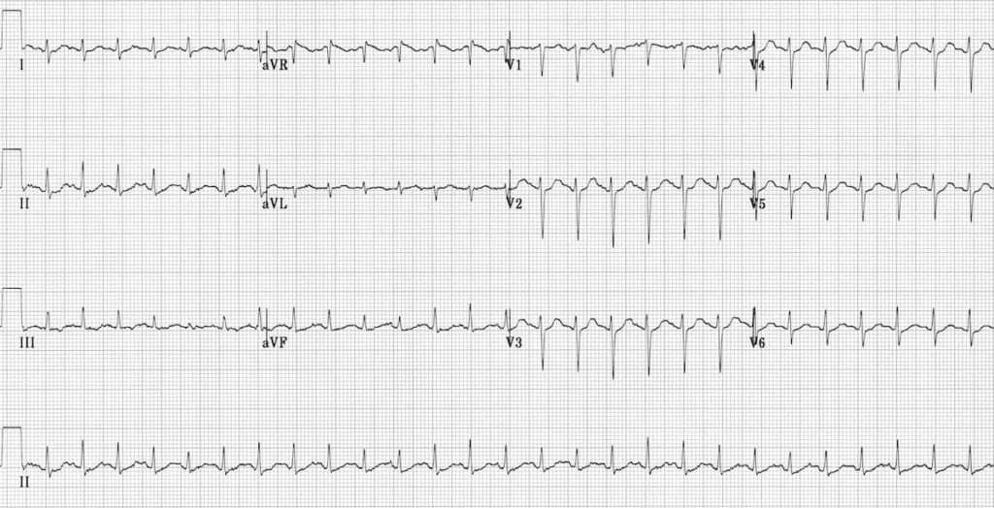
From Life in the Fast Lane (https://litfl.com/sinus-tachycardia-ecg-library/)

2. Chest X-Ray: normal
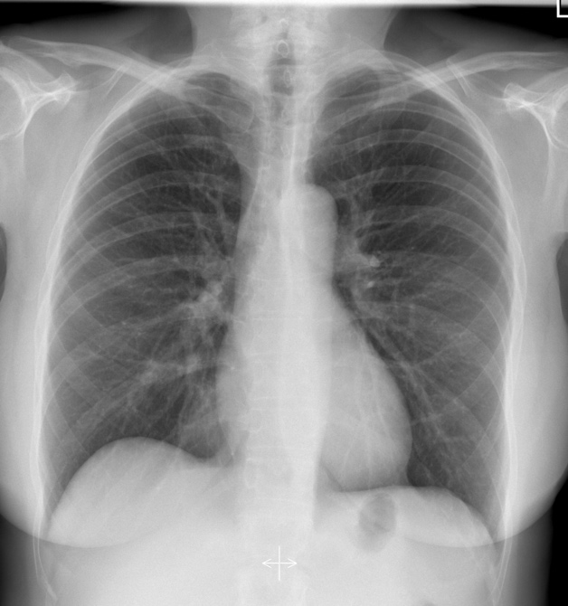
Case courtesy of Dr Usman Bashir, Radiopaedia.org, rID: 18394

3. CT abdo/pelvis: Large (11 mm) obstructing calculus in the left ureter with left hydro-ureteronephrosis.
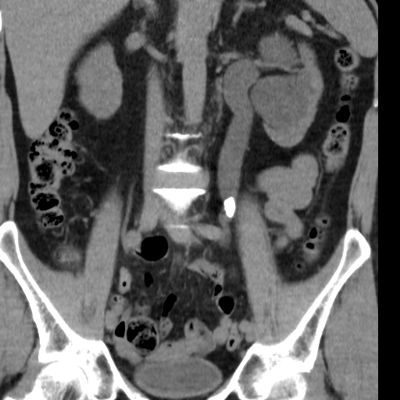
Image courtesy of Dr Roberto Schubert, Radiopaedia.org, rID: 16407

4. Ultrasound: Hydronephrosis
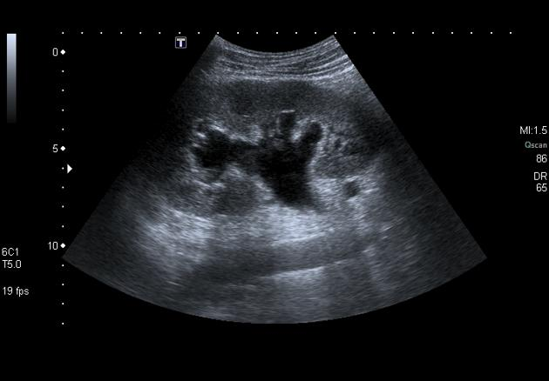
Image courtesy of Dr Amr Refat, Radiopaedia.org, rID: 25562

Appendix C: Facilitator Cheat Sheet & Debriefing Tips

Include key errors to watch for and common challenges with the case. List issues expected to be part of the debriefing discussion. Supplemental information regarding any relevant pathophysiology, guidelines, or management information that may be reviewed during debriefing should be provided for facilitators to have as a reference.

Discussion points for residents/trainees
- Can you summarize the case for us?
- How did the case go as a team? How did it go for you as an individual?
- What went well during the simulated resuscitation?
- What did not go so well? Anything that you would have done differently?
Medical Knowledge
- What is your approach to shock and how does POCUS help confirming your diagnosis?
  - Septic/distributive shock
  - Hemorrhagic/hypovolemic shock
  - Obstructive shock e.g. cardiac tamponade
  - Cardiogenic shock
  - Anaphylactic shock
  - POCUS
    - Cardiac tamponade
    - LV contractility (hypokinetic vs hyperkinetic)
    - RV dilation/strain and RV outflow tract obstruction
    - IVC compressibility and variation with respiration
    - FAST for free fluid
- What are your choices of vasopressors in response to septic shock? What are your considerations in the context of patient’s cardiac history? Discuss vasopressor mechanism of actions.
  - Norepinephrine (good 1st choice for most patients with septic shock, mostly alpha, some beta-1)
  - Phenylepherine (pure alpha agonist; good for vasodilatory or distributive shock; similar outcomes in septic patients compared to norepi)
  - Epinephrine (powerful beta receptor agonist/inotropic agent; caution if systolic heart failure)
  - Vasopressin (pure vasoconstrictor, non-catecholamine; considered as an adjunct vasopressor for shock and may improve renal perfusion)
- What are your target goals of resuscitation (things to consider)?
  - Fluids and vasopressors to keep MAP >=65 while end-organ perfusion maintained
    - Consider POCUS, pulse pressure variation, etc. to guide management
  - Lactate clearance
  - Urine output vs capillary refill time normalization
- Were you concerned about the patient’s initial HR being 95?
  - Yes, because patient was also taking beta-blocker, masking tachycardia
- How did the patient’s cardiac history change your approach to fluids and vasopressors?
  - Careful fluid bolus, expect septic cardiomyopathy, early vasopressors.
- How would your team-based approach change during the COVID pandemic?
  - PPE precaution and consider COVID as a differential diagnosis

References

1. Tintinalli’s Emergency Medicine. Chapters 50, 56, and 89
2. EM Cases. “Episode 122 Sepsis & Septic Shock – What Matters Live from EM Cases Course”, with Dr. Sara Gray
3. Kane SP and Benken ST. “Vasopressor Selection in Septic Shock”, Society of Critical Care Medicine
4. Farkas J. “Vasopressors”, The Internal Book of Critical Care

